

**MAULANA ABUL KALAM AZAD UNIVERSITY OF TECHNOLOGY,**

**WEST BENGAL**

**NH-12 (Old NH-34), Simhat, Haringhata, Nadia -741249**

**DEPARTMENT OF INFORMATION TECHNOLOGY**

**Subject: Internet Technology Lab**

**NAME: Lokesh Ghosh**

**COURSE: BCA (3rd Year/5th Sem)**

**ROLL NO: 30001220008**

**REG. NO: 203001001210008**

**MAIL ID: [ghoshlokesh57@gmail.com](mailto:ghoshlokesh57@gmail.com)**

**PHONE NO: 9647554315**

**YEAR: 2020-2021**

1. Write a program in JavaScript to convert from Celsius to Fahrenheit.

Code:

|  |
| --- |
| <!-- 1. Write a program in JavaScript to convert from Celsius to Fahrenheit. -->  <!DOCTYPE html>  <html>  <head>  <meta charset="utf-8">  <title>Write a JavaScript program to convert temperatures to and from celsius, fahrenheit</title>  </head>  <body>  <script>  function cToF(celsius)  {  var cTemp = celsius;  var cToFahr = cTemp * 9 / 5 + 32;  var message = cTemp+'\xB0C is ' + cToFahr + ' \xB0F.';  alert(message);  }    function fToC(fahrenheit)  {  var fTemp = fahrenheit;  var fToCel = (fTemp - 32) * 5 / 9;  var message = fTemp+'\xB0F is ' + fToCel + '\xB0C.';  alert(message);  }  cToF(60);  fToC(45);  </script>  </body>  </html> |

Output:

|  |
| --- |
|  |

1. Write a program in JavaScript to check whether a year is leap year or not.

Code:

|  |
| --- |
| <!-- 2. Write a program in JavaScript to check whether a year is leap year or not. -->  <!DOCTYPE html>  <html lang="en">  <head>  <meta charset="UTF-8" />  <meta http-equiv="X-UA-Compatible" content="IE=edge" />  <meta name="viewport" content="width=device-width, initial-scale=1.0" />  <title>Document</title>  </head>  <body>  <script>  // program to check leap year  function checkLeapYear(year) {  //three conditions to find out the leap year  if ((0 == year % 4 && 0 != year % 100) || 0 == year % 400) {  alert(year + " is a leap year");  } else {  alert(year + " is not a leap year");  }  }  // take input  const year = prompt("Enter a year:");  checkLeapYear(year);  </script>  </body>  </html> |

Input:

|  |
| --- |
|  |

Output:

|  |
| --- |
|  |

Input:

|  |
| --- |
|  |

Output:

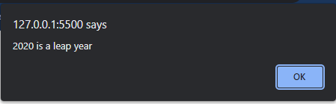

1. Write a program in JavaScript to show the use of break and continue.

Code:

|  |
| --- |
| <!--3. Write a program in JavaScript to show the use of break and continue. -->  <!DOCTYPE html>  <html lang="en">  <head>  <meta charset="UTF-8">  <meta http-equiv="X-UA-Compatible" content="IE=edge">  <meta name="viewport" content="width=device-width, initial-scale=1.0">  <title>Document</title>  </head>  <body>  <p id="ele"></p>  <script>  // program to print the value of i  for (let i = 1; i <= 5; i++) {  // break condition    if (i == 3) {  break;  }else if(i==2){  i++;  continue;  }    console.log(i);  }  </script>  </body>  </html> |

Output:

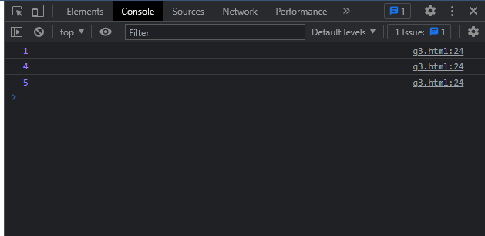

1. Write a program in JavaScript to print the following pattern:

*

* *

* * *

* * * *

Code:

|  |
| --- |
| <!-- 4. Write a program in JavaScript to print the following pattern:  *  * *  * * *  * * * *  -->  <!DOCTYPE html>  <html lang="en">  <head>  <meta charset="UTF-8" />  <meta http-equiv="X-UA-Compatible" content="IE=edge" />  <meta name="viewport" content="width=device-width, initial-scale=1.0" />  <title>Document</title>  </head>  <body>  <p id="pattern"></p>  <script>  let n = 5;  let string = "";  for (let i = 1; i <= n; i++) {  for (let j = 0; j < i; j++) {  string += "*";    }    string += "<br>";  }  console.log(string);  document.getElementById("pattern").innerHTML = string;  </script>  </body>  </html> |

Output:

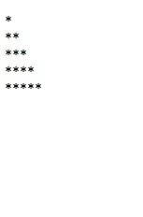

1. Write a program in JavaScript to concatenate two arrays.

Code:

|  |
| --- |
| <!--5. Write a program in JavaScript to concatenate two arrays. -->  <!DOCTYPE html>  <html lang="en">  <head>  <meta charset="UTF-8">  <meta http-equiv="X-UA-Compatible" content="IE=edge">  <meta name="viewport" content="width=device-width, initial-scale=1.0">  <title>Document</title>  </head>  <body>  <h3 class="oldcar">  These are old car List  </h3>  <p id="oldcarcontent"></p>  <h3 class="Newcar">  These are new car List  </h3>  <p id="newcarcontent"></p>  <h3 class="Newcar">  These are all car List  </h3>  <p id="allcarcontent"></p>  <script>  let newcar=["Tata Nexon ", " Mahindra Thar . "];  let oldcar=[" Honda City ", " MS Alto 800"];    let totalcar=newcar+oldcar;    document.getElementById("oldcarcontent").innerHTML=oldcar;  document.getElementById("newcarcontent").innerHTML=newcar;  document.getElementById("allcarcontent").innerHTML=totalcar;  console.log(totalcar);  </script>  </body>  </html> |

Output:

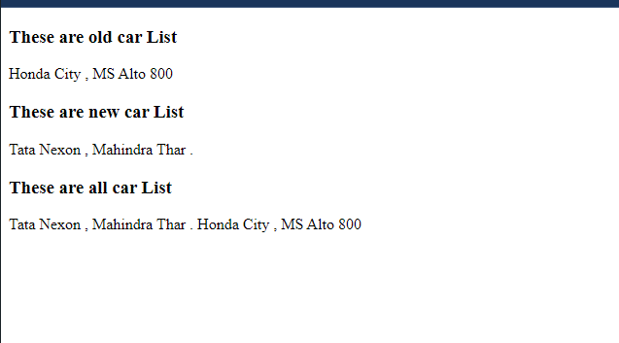

1. Write a program in JavaScript to find the reverse of a string.

Code:

|  |
| --- |
| <!-- 6. Write a program in JavaScript to find the reverse of a string. -->  <!DOCTYPE html>  <html lang="en">  <head>  <meta charset="UTF-8">  <meta http-equiv="X-UA-Compatible" content="IE=edge">  <meta name="viewport" content="width=device-width, initial-scale=1.0">  <title>Document</title>  </head>  <body>  <h1>String</h1>  <h3 id="string">MAKAUT</h3>  <h1>Reverse String</h1>  <h3 id="revstring"></h3>  <script>  let s = document.getElementById("string").innerHTML;  let ans="";  for(let i=s.length-1;i>=0;i--){  console.log(s[i]);  ans+=s[i];  document.getElementById("revstring").innerHTML=ans;  }  </script>  </body>  </html> |

Output:

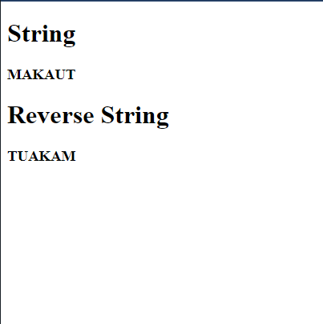

1. Write a program in JavaScript to display alert box.

Code:

|  |
| --- |
| <!-- 7. Write a program in JavaScript to display alert box. -->  <!DOCTYPE html>  <html lang="en">  <head>  <meta charset="UTF-8">  <meta http-equiv="X-UA-Compatible" content="IE=edge">  <meta name="viewport" content="width=device-width, initial-scale=1.0">  <title>Document</title>  </head>  <body>  <script>  alert("hey there this is alert box");  </script>  </body>  </html> |

Output:

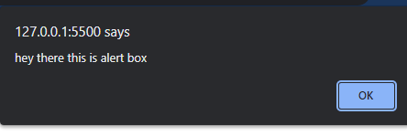

1. Write a program in JavaScript to display confirmation box.

Code:

|  |
| --- |
| <!-- 8. Write a program in JavaScript to display confirmation box. -->  <!DOCTYPE html>  <html lang="en">  <head>  <meta charset="UTF-8">  <meta http-equiv="X-UA-Compatible" content="IE=edge">  <meta name="viewport" content="width=device-width, initial-scale=1.0">  <title>Document</title>  </head>  <body>  <script>  confirm("This is conformation box");  </script>  </body>  </html> |

Output:

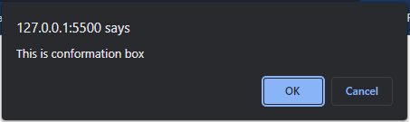

1. Write a program in JavaScript to display prompt box.

Code:

|  |
| --- |
| <!-- 9. Write a program in JavaScript to display prompt box. -->  <!DOCTYPE html>  <html lang="en">  <head>  <meta charset="UTF-8">  <meta http-equiv="X-UA-Compatible" content="IE=edge">  <meta name="viewport" content="width=device-width, initial-scale=1.0">  <title>Document</title>  </head>  <body>  <script>  prompt("This is just a prompt box")  </script>  </body>  </html> |

Output:

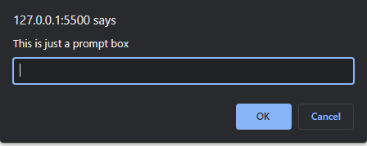

1. Write a program in JavaScript to show the use of onkeypress event.

Code:

|  |
| --- |
| <!-- 10. Write a program in JavaScript to show the use of onkeypress event. -->  <!DOCTYPE html>  <html lang="en">  <head>  <meta charset="UTF-8">  <meta http-equiv="X-UA-Compatible" content="IE=edge">  <meta name="viewport" content="width=device-width, initial-scale=1.0">  <title>Document</title>  </head>  <body>  <h3>On clicking in the text box a function will trigger</h3>  <input type="text" onkeypress="trigger()">  <h3 id="trig"></h3>  <script>  function trigger(){    document.getElementById("trig").innerHTML="This is effect after clicking in the text box";  }  </script>  </body>  </html> |

Output:

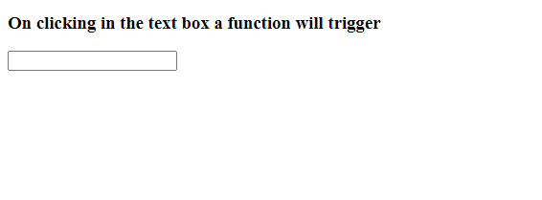

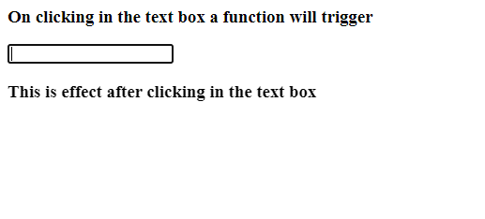

1. Write a program in JavaScript to perform the textbox required validation.

Code:

|  |
| --- |
| <!-- 11. Write a program in JavaScript to perform the textbox required validation. -->  <!DOCTYPE html>  <html lang="en">  <head>  <meta charset="UTF-8">  <meta http-equiv="X-UA-Compatible" content="IE=edge">  <meta name="viewport" content="width=device-width, initial-scale=1.0">  <title>Document</title>  </head>  <body>  <form name="myForm" action=" "onsubmit="return validateTheForm()" method="post">  Name: <input type="text" name="Name">  <input type="submit" value="Submit">  </form>  <script>  function validateTheForm(){  let x=document.forms["myForm"]["Name"].value;  if(x==""){  alert("Please Fill all the field");  return false;  }  }  </script>  </body>  </html> |

Output:

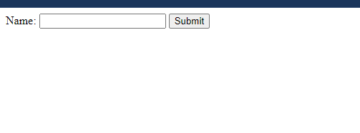

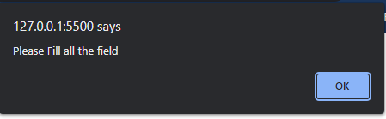

1. Write a program in JavaScript to validate an email.

Code:

|  |
| --- |
| <!-- 12. Write a program in JavaScript to validate an email. -->  <!DOCTYPE html>  <html lang="en">  <head>  <meta charset="utf-8">  <title>JavaScript form validation - checking email</title>  </head>  <body onload='document.form1.text1.focus()'>  <div class="mail">  <h2>Input an email and Submit</h2>  <form name="form1" action="#">  <ul>  <li><input type='text' name='text1'/></li>  <li>&nbsp;</li>  <li class="submit"><input type="submit" name="submit" value="Submit" onclick="ValidateEmail(document.form1.text1)"/></li>  <li>&nbsp;</li>  </ul>  </form>  </div>  <script>  function ValidateEmail(inputText)  {  var mailformat = /^\w+([\.-]?\w+)*@\w+([\.-]?\w+)*(\.\w{2,3})+$/;  if(inputText.value.match(mailformat))  {  alert("Valid email address!");  document.form1.text1.focus();  return true;  }  else  {  alert("You have entered an invalid email address!");  document.form1.text1.focus();  return false;  }  }  </script>  </body>  </html> |

Output:

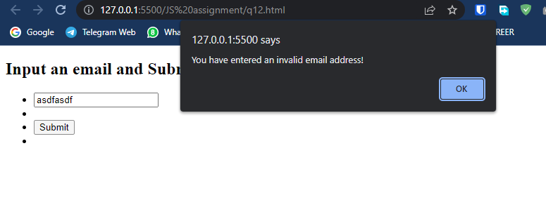

1. Write a program in JavaScript to validate letter and number in a text field.

Code:

|  |
| --- |
| <!-- 13. Write a program in JavaScript to validate letter and number in a text field. -->  <!DOCTYPE html>  <html lang="en">  <head>  <meta charset="utf-8" />  <title>JavaScript form validation - checking all letters and numbers</title>  </head>  <body onload="document.form1.text1.focus()">  <div class="mail">  <h2>Enter your Registration Number and Submit</h2>  <form name="form1" action="#">  <ul>  <li><input type="text" name="text1" /></li>  <li class="rq">*Enter numbers and alphabets only.</li>  <li>&nbsp;</li>  <li>  <input  type="submit"  name="submit"  value="Submit"  onclick="alphanumeric(document.form1.text1)"  />  </li>  <li>&nbsp;</li>  </ul>  </form>  </div>  <script>  function alphanumeric(inputtxt) {  var letters = /^[0-9a-zA-Z]+$/;  if (inputtxt.value.match(letters)) {  alert("Your registration number have accepted : you can try another");  document.form1.text1.focus();  return true;  } else {  alert("Please input alphanumeric characters only");  return false;  }  }  </script>  </body>  </html> |

Output:

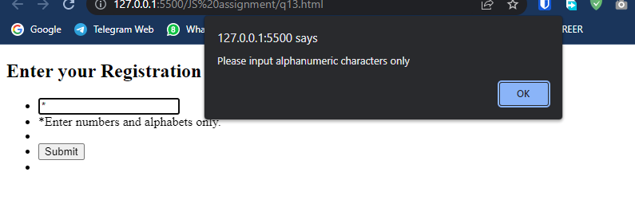

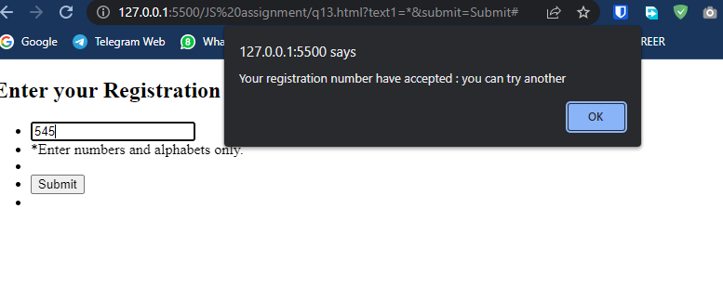

1. Write a program in JavaScript to validate an ip address.

Code:

|  |
| --- |
| <!-- 14. Write a program in JavaScript to validate an ip address. -->  <!-- Write a program in JavaScript to validate an ip address. -->  <!DOCTYPE html>  <html lang="en">  <head>  <meta charset="utf-8">  <title>JavaScript form validation - checking ip address</title>  </head>  <body>  <h2>Input Ip addres</h2>  <form name="form1" action="#">  <ul>  <input type='text' name='text1' />  <input type="submit" name="submit" value="Submit" onclick="ValidateIPaddress(document.form1.text1)" />  </ul>  </form>  <script>  function ValidateIPaddress(inputText) {  var IP = /^(25[0-5]|2[0-4][0-9]|[01]?[0-9][0-9]?)\.(25[0-5]|2[0-4][0-9]|[01]?[0-9][0-9]?)\.(25[0-5]|2[0-4][0-9]|[01]?[0-9][0-9]?)\.(25[0-5]|2[0-4][0-9]|[01]?[0-9][0-9]?)$/;  if (inputText.value.match(IP)) {  alert("Valid IP");  document.form1.text1.focus();  return true;  }  else {  alert("Invalid IP");  document.form1.text1.focus();  return false;  }  }  </script>  </body>  </html> |

Output:

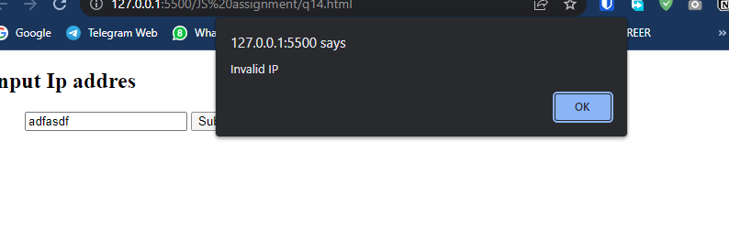

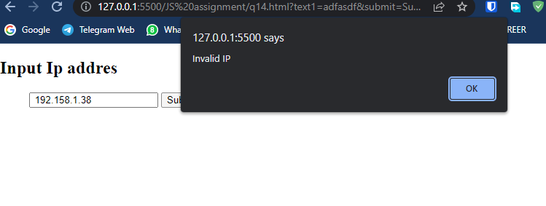

1. Write a program in JavaScript to disable the back button.

Code:

|  |
| --- |
| <!-- 15.Write a program in JavaScript to disable the back button. -->  <!DOCTYPE html>  <html>  <head>  <title> Blocking Back Button using javascript</title>  </head>  <body>  <h1>Block back Button </h2>  <p>  Click here to Goto  <a href="q12.html">  Link to second page  </a>  </p>  <script>  window.history.forward();  function noBack() {  window.history.forward();  }  </script>  </body>  </html> |

Output:

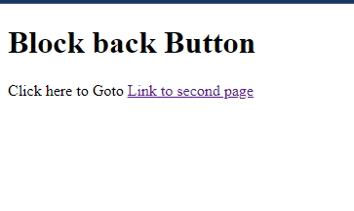

1. Write a program in JavaScript to disable mouse right click.

Code:

|  |
| --- |
| <!-- 16.Write a program in JavaScript to disable mouse right click. -->  <!DOCTYPE HTML>  <html>  <head>  <title>  Disable right click on my web page  </title>  </head>    <body style = "text-align:center;">    <h1>  Click on the button to disable right click  </h1>      <button onclick = "run_func()">  Disable  </button>    <p id = "down" style =  "color:green; font-size: 20px; font-weight: bold;">  </p>    <script>  var el_up = document.getElementById("up");  var el_down = document.getElementById("down");  el_up.innerHTML = "Click on the button to disable right click";    function run_func() {  document.addEventListener('contextmenu',  event => event.preventDefault());  el_down.innerHTML = "Right click disabled";  }  </script>  </body>  </html> |

Output:

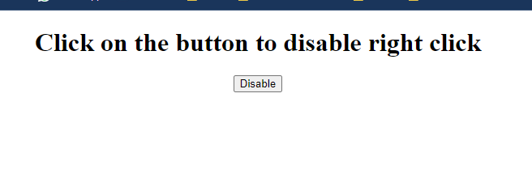

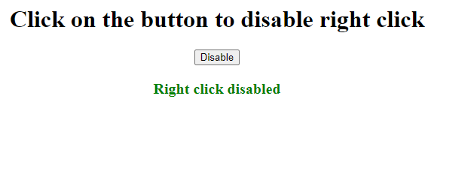

1. Write a program in JavaScript for date countdown timer.

Code:

|  |
| --- |
| <!-- 17.Write a program in JavaScript for date countdown timer. -->  <!DOCTYPE HTML>  <html>  <head>  <title>Timer</title>  </head>  <body>  <h2>  Timer  </h2>  <p id="demo"></p>  <script>  var deadline = new Date("Nov 19, 2030 15:37:25").getTime();  var x = setInterval(function () {  var now = new Date().getTime();  var t = deadline - now;  var days = Math.floor(t / (1000 * 60 * 60 * 24));  var hours = Math.floor((t % (1000 * 60 * 60 * 24)) / (1000 * 60 * 60));  var minutes = Math.floor((t % (1000 * 60 * 60)) / (1000 * 60));  var seconds = Math.floor((t % (1000 * 60)) / 1000);  document.getElementById("demo").innerHTML = days + "d "  + hours + "h " + minutes + "m " + seconds + "s ";  }, 1000);  </script>  </body>  </html> |

Output:

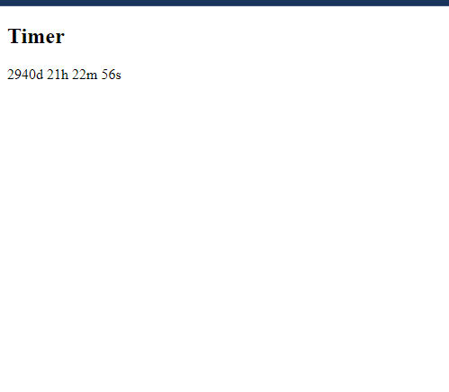

1. Write a program in JavaScript for checkbox validation.

Code:

|  |
| --- |
| <!-- 18.Write a program in JavaScript for checkbox validation. -->  <!DOCTYPE html>  <html lang="en">  <head>  <meta charset="UTF-8">  <meta http-equiv="X-UA-Compatible" content="IE=edge">  <meta name="viewport" content="width=device-width, initial-scale=1.0">  <title>Checkbox validation</title>  </head>  <body>  <form action="#" onsubmit="return checkCheckBoxes(this);">  <p><input type="CHECKBOX" name="MyCheckbox" value="This..."></p>  <p><input type="SUBMIT"></p>  <p id="alert"></p>  </form>  <script>  function checkCheckBoxes(theForm) {  if (  theForm.MyCheckbox.checked == false) {  document.getElementById("alert").innerHTML="Not Cheaked";  document.getElementById("alert").style.color="red";  return false;  } else {  document.getElementById("alert").innerHTML="Cheaked";  document.getElementById("alert").style.color="green";  }  }  </script>  </body>  </html> |

Output:

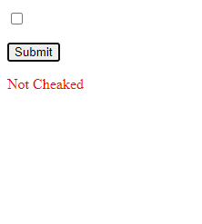

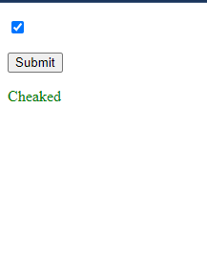

1. Write a program in JavaScript to check whether a radio button is selected or not.

Code:

|  |
| --- |
| <!-- 19.Write a program in JavaScript to check whether a radio button is selected  or not. -->  <html>  <body>  <input type="radio" id="Radio" value="Radio">Radio  <button type="button" onclick=" checkButton()"> Submit </button>  <h3 id="aleart" style="color:green"> </h3>  </body>  <script>  function checkButton() {  if (document.getElementById('Radio').checked) {  document.getElementById("aleart").innerHTML  = document.getElementById("Radio").value  + " is checked";  }  else {  document.getElementById("aleart").innerHTML  = "Radio is not checked";  document.getElementById("aleart").style.color  = "red";  }  }  </script>  </html> |

Output:

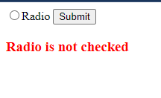

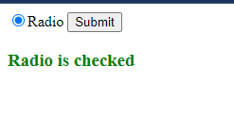

1. Write a program in JavaScript to print a page.

Code:

|  |
| --- |
| <!-- 20.Write a program in JavaScript to print a page. -->  <!DOCTYPE html>  <html>  <head>  <title>Print a Page</title>  </head>  <body>  <p>This is the print content.</p>  <button onclick="display()">Click to Print</button>  <script>  function display() {  window.print();  }  </script>  </body>  </html> |

Output:



